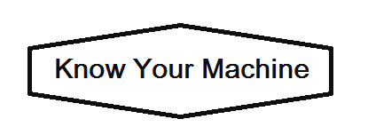

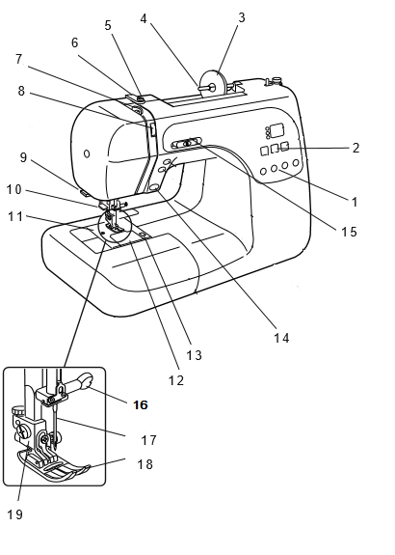
1 – Pattern selection buttons
2 – Stitch adjustment buttons
3 – Spool holder/spool cap
4 – Spool pin
5 – Bobbin winding thread guide
6 – Thread guide
7 – Thread take-up lever
8 – Tension regulating dial
9 – Thread cutter
10 – Needle threader
11 – Needle plate/Throat plate
12 – Bobbin cover (plate)
13 – Bobbin cover (plate) release button
14 – Reverse button/Backstitch
15 – Speed control slider
16 – Needle clamp screw
17 – Needle
18 – Presser foot
19 – Foot holder/Ankle
20 – Bobbin winder (spindle)
21 – Hand wheel
22 – Power switch
23 – Buttonhole lever
24 – Presser foot lifter
25 – Feed (Draw in yourself.)
