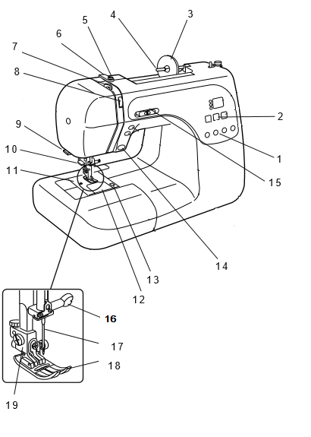
1 – ______________________________
2 – ______________________________
3 – ______________________________
4 – ______________________________
5 – ______________________________
6 – ______________________________
7 – ______________________________
8 – ______________________________
9 – ______________________________
10 – ______________________________
11 – ______________________________
12 – ______________________________
13 – ______________________________
14 – ______________________________
15 – ______________________________
16 – ______________________________
17 – ______________________________
18 – ______________________________
19 – ______________________________
20 – ______________________________
21 – ______________________________
22 – ______________________________
23 – ______________________________
24 – ______________________________
25--_______________________________
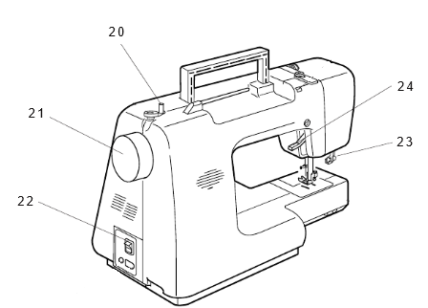
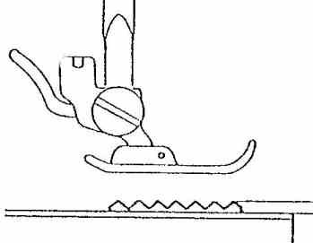
25

